# **Feynn Labs - Project 2**

# **Market Segmentation Analysis – Case Study – Fast Food**

# **Zainab Saeed**

# **Date: 27th October, 2024**

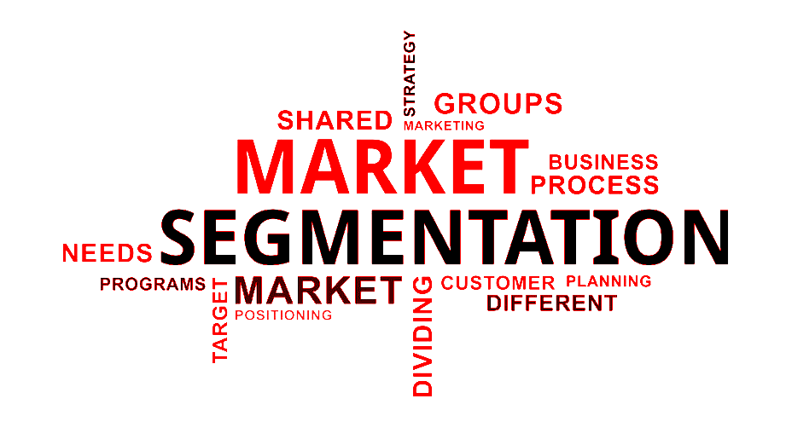

**Contents**

**Step 1: Deciding (not) to Segment** 4

**Step 2: Specifying the Ideal Target Segment** 6

2.1 Overview of Group Criteria: 6

2.2 Group Attractiveness Factors: 6

2.3 Strategic Thoughts: 6

**Step 3: Collecting Data** 7

3.1 Data Set Overview:. 7

**Step** **4: Exploring Data** 8

4.1 Glimpse at the Data 8

4.2 Data Cleaning: 9

4.3 Descriptive analysis: 10

4.4 Preprocessing: 11

4.5 Principal Component Analysis (PCA): 12

**Step 5: Extracting Segments** 12

1. Grouping Consumers: 12

2. Distance-Based Methods: 13

3. Model-Based Methods: 13

4. Integrated Variable Selection Algorithms: 13

5. Data Structure Analysis: 13

**Step 6: Profiling Segments** 13

6.1 Figuring Out Key Traits of Market Segments 14

6.2 Old School Ways to Profile Market Segments 14

6.3 Profiling Segments with Visuals 14

**Step 7: Describing Segments** 15

7.1 Getting a Full Picture of Market Segmentation 15

7.2 Types of Market Segmentation 16

7.2 Visuals for Market Segmentation Description 19

7.3 Checking Segment Variables 19

7.4 Predicting Segments with Variables 20

**Step 8: Selecting the Target Segment(s)** 20

8.1 Get the Segmentation Team Together 20

8.2 Figure Out Potential Target Markets 20

8.3 Make Sure It Meets Knock-Out Criteria 21

8.4 Agree on Values for Attractiveness Criteria of Segments 21

8.5 Check Organizational Competitiveness for Each Segment 21

8.6 Figure Out Overall Attractiveness of Segments 21

8.7 Calculate Organizational Competitiveness for Each Segment 21

8.8 Plot Values on a Segment Evaluation Plot 21

8.9 Make a Preliminary Selection of Target Segments 22

8.10 Check Compatibility Among the Chosen Segments 22

8.11 Present to the Advisory Committee 22

8.12 Finalize Target Market Segments 22

**Step 9: Customising the Marketing Mix** 22

9.1 Understand Implications for Marketing Mix Decisions 22

9.2 Product 23

9.3 Price 23

9.4 Place 23

9.5 Promotion 24

# **Market Segmentation - Case Study**

**Problem Statement:** McDonald's aims to leverage market segmentation analysis using empirical data from a survey research dataset, originally collected for investigating brand image. The challenge is to identify and understand distinct consumer segments with varying perceptions of McDonald's. This includes determining if negative perceptions exist within specific segments and uncovering the key drivers behind such negativity.

**Objective:**

• **Segmentation Identification:** Identify distinct consumer segments based on brand perceptions of McDonald's.

• **Perception Analysis:** Categorize segments into positive and negative perceptions for targeted strategies.

• **Key Driver Identification:** Analyze segments with negative perceptions to identify key drivers of dissatisfaction.

• **Insightful Marketing Strategy:** Provide actionable insights for tailored marketing strategies to strengthen positive perceptions or modify negative ones.

• **Brand Enhancement:** Enhance McDonald's brand management by addressing specific consumer segment perceptions effectively.

**Steps of Market Segmentation Analysis:**

**Step 1: Deciding (not) to Segment**

**Step 2: Specifying the Ideal Target Segment**

**Step 3: Collecting Data**

**Step 4: Exploring Data**

**Step 5: Extracting Segments**

**Step 6: Profiling Segments**

**Step 7: Describing Segments**

**Step 8: Selecting the Target Segment(s)**

**Step 9: Customising the Marketing Mix**

## **Step 1: Deciding (not) to Segment**

1. **Implications of Sticking to Market Segmentation:**

* Long-Term Commitment: When you commit to market segmentation, it's like entering a long-term relationship. Companies such as McDonald's gotta really take this seriously, which means they gotta be flexible and ready to make big changes in how they operate.

1. **Cost Considerations:**

Trying to implement market segmentation brings along pretty hefty costs. This includes doing research, gathering consumer insights through surveys, making custom marketing materials, and changing up current products and how they communicate with customers.

1. **Profitability Justification:**

It's super important that the advantages of segmentation are worth the costs that come with it. The company needs to make sure that using a segmented strategy is gonna make more money than if they just went with a non-segmented approach.

1. **Organizational Alignment:** For segmentation to work well, McDonald's might need to tweak its internal setup, focusing more on market segments instead of just on product lines. This could mean coming up with new products, changing pricing strategies, and optimizing how they get their products out to customers.
2. **Executive Decision-Making:**

Since a segmentation strategy has big effects, decisions need to come from the top of management and be clearly shared throughout all levels of the organization.

1. **Implementation Barriers**

* **Senior Management Challenges:** One of the main challenges for effective segmentation is when senior leaders aren’t actively involved or committed. Without their backing and resources, trying to push a segmentation strategy can really fall flat.

**Cultural Resistance:** The culture inside the organization can create hurdles, especially if there’s pushback against change, not enough focus on what the market needs, and poor communication among departments. This kind of resistance can hold back innovation and make segmentation efforts tougher.

1. **Training and Expertise Deficiencies:** If management and teams lack training and understanding of market segmentation basics, it can lead to misalignment and not-so-great strategies. It’s really important to make sure staff get the training they need to break through this obstacle.
2. **Resource Limitations:** Money issues and not being able to make the necessary structural changes can put a serious dent in how well market segmentation initiatives work. McDonald's has to put enough resources to tackle these problems properly.
3. **Operational Inefficiencies:** If goals aren't clear, planning is weak, and processes aren't organized, it can slow down the segmentation process. It’s crucial to set clear goals and have a solid framework to guide the implementation.
4. **Interpersonal Dynamics:** The people inside the organization are key to making segmentation strategies successful. Personal conflicts, high turnover, or lack of teamwork can create hurdles that might be really tough to deal with.

## **Step 2: Specifying the Ideal Target Segment**

### **2.1 Overview of Group Criteria:**

McDonald’s team gotta figure out what makes a market group interesting. This means they need to set specific things to check when looking at possible target groups.

**Key Things to Look At:**

1. **Homogeneity:** People in the group should have similar traits that connect to what McDonald’s offers.
2. **Distinctiveness:** Target groups gotta stand out a lot from other ones so that marketing works well.
3. **Size:** Groups should be big enough to make special marketing worth it.
4. **Alignment with Brand:** People in the group should like fast food and wanna eat at McDonald’s.
5. **Identifiability:** There should be ways to spot group members among all the other consumers out there.
6. **Reachability:** The group needs to be easy to reach through current channels of communication and distribution.

### **2.2 Group Attractiveness Factors:**

It’s really important that people see McDonald’s in a good light. The best group should have fans of McDonald’s but also folks who come by often.

McDonald’s might wanna look into groups that don’t have a great opinion about the brand now, trying to get what they think and change their mind for the better.

### **2.3 Strategic Thoughts:**

With not too much data on how the brand is seen, the main signs of attractiveness focus on how much people like McDonald’s and how often they show up. These details will help in picking the target groups in the next steps of the analysis.

**Conclusions:** By using these detailed evaluation points, McDonald’s can make smart choices about market groups that are not just profitable but also fit well with what the company is good at.

## **Step 3: Collecting Data**

### **3.1 Data Set Overview:** This study looks at 1,453 adult Australians, checking out how they feel about McDonald's based on a bunch of traits like YUMMY, CONVENIENT, SPICY, FATTENING, GREASY, FAST, CHEAP, TASTY, EXPENSIVE, HEALTHY, and DISGUSTING. People shared their thoughts about these traits by saying either YES or NO.

**Demographic Information:** Besides the trait responses, participants also shared some demographic stuff, like AGE and GENDER. While this data gives a peek into how consumers see things, having more details about their dining habits and media use would really help paint a fuller picture of the market segments.

**Segmentation Variables:**

* The main way to split up the data in this study is through those traits, with each person's answer coded (1 for YES and 0 for NO). This gives a really layered view of how people feel about McDonald's.
* Other details like age and gender act as helpful background info, making it easier to analyze the different segments.

**Segmentation Criteria:**

* For segmentation, we look at geographic, socio-demographic, psychographic, and behavioral factors. This helps us get a clearer view of the target market.
* This method shows the difference between common sense and data-driven segmentation, where data-driven segmentation uses a bunch of variables to spot different consumer groups.

**Considerations for Survey Data:**

* **Choice of Variables:** Picking the right survey variables is super important to avoid messed up results and make the segmentation analysis better.
* **Response Options:** How we set up the response options matters too. Clear and fair choices help get accurate answers.
* **Response Styles:** We gotta be aware of any biases in responses (like people just agreeing or wanting to seem good) to make sure the insights we get from the data are solid.
* **Sample Size:** Having enough participants is key for good statistical analysis, balancing being representative and not breaking the bank.

**Utilization of Data Sources:**

* The study mainly uses survey data since it's cheaper and easier to gather, but it also knows that self-reported data can have biases.
* Mixing in some internal data and experimental studies could really boost the segmentation insights by giving a fuller view of how consumers behave.

## **4. Exploring Data**

### **4.1 Glimpse at the Data**

* **Purpose:** To understand the data, identify patterns, anomalies, and relationships.
* **What It Involves:**
* **Visualization:** Using plots (histograms, scatter plots, box plots) to see distributions, correlations, and outliers.
* **Identifying Patterns and Anomalies:** Looking for trends, correlations, and unusual data points.
* **Libraries Used:** Pandas, Matplotlib, Seaborn
* **Processes:**
* **Visualization:** Creating plots with Matplotlib and Seaborn
* **Correlation Analysis:** Using df.corr() to find correlations between features.

### **4.2 Data Cleaning:**

* **Purpose:** To improve data quality by removing or correcting inaccuracies.
* **What It Involves:**
* **Handling Missing Data:** Deciding whether to fill in missing values (imputation), drop them, or mark them.
* **Removing Duplicates:** Identifying and eliminating duplicate records.
* **Correcting Errors:** Fixing data entry errors or inconsistencies.
* **Dealing with Outliers:** Identifying and potentially removing outliers that could skew the results.
* **Libraries Used:** Pandas
* **Processes:**
* **Handling Missing Data:** Filling (df.fillna()) or dropping (df.dropna()) missing values.
* **Removing Duplicates:** Using df.drop_duplicates().
* **Correcting Errors:** Applying functions to columns to correct data (df['column'].apply(lambda x: ...)).
* **Outlier Handling:** Identifying outliers using statistical methods and possibly removing them.

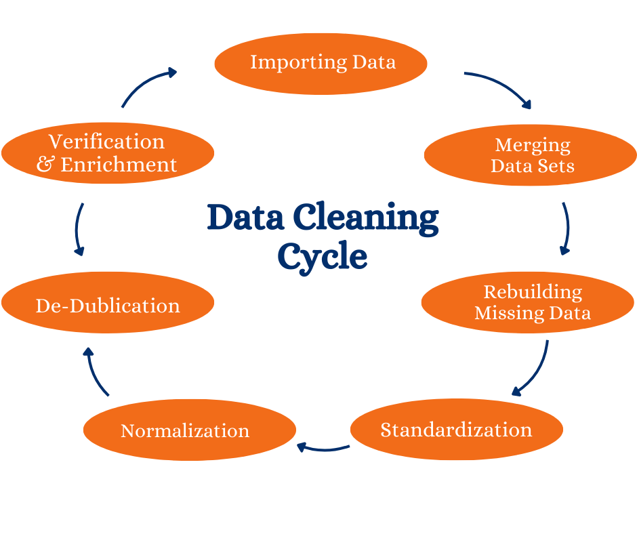

### **4.3 Descriptive analysis:**

* **Descriptive Statistics:** Summarizing data using means, medians, modes, ranges, and standard deviations.
* **Descriptive Statistics:** Using Pandas for basic statistics (df.describe(), df.mean(), df.median()).
* **Data Summarization:** Provides an overview of the dataset's structure, including sample size, data types, and the presence of missing values. Tools like df.info() and df.describe() in Python's Pandas library are commonly used for this purpose.
* **Univariate Analysis:** Focuses on individual variables, summarizing their central tendency (mean, median, mode), dispersion (range, variance, standard deviation), and frequency distributions. Histograms and bar charts are typical visualization tools for this analysis.
* **Bivariate and Multivariate Analysis:** Examines relationships between two or more variables. Techniques include scatter plots, correlation matrices, and cross-tabulations. This helps in understanding how variables interact with each other.
* **Data Visualization:** Integral to descriptive analysis, it uses graphical representations like histograms, box plots, scatter plots, and heatmaps to visualize data trends, patterns, and outliers. Libraries such as Matplotlib and Seaborn in Python are widely used for crafting these visualisations.
* **Handling Missing Values:** Identifying and addressing missing data through methods like deletion, imputation, or analysis based on present data, to ensure the quality and integrity of the analysis.
* **Correlation Analysis:** Identifies the degree to which two variables are related. This involves computing correlation coefficients to understand the strength and direction of the relationships.
* **Normality Tests:** Statistical tests and plots, such as Q-Q plots, are used to check if the data distribution deviates from a normal distribution, which is crucial for certain types of statistical inference.

### **4.4 Preprocessing:**

* **Purpose:** To transform raw data into a format more suitable for modeling.
* What It Involves:
* Feature Encoding: Converting categorical data into numerical format (e.g., one-hot encoding).
* Feature Scaling/Normalization: Scaling features to a uniform range (e.g., 0-1 scaling, standardization).
* Splitting Data: Dividing data into training and test sets.
* Feature Engineering: Creating new features from existing ones to improve model performance.
* **Libraries Used:** Pandas, Scikit-learn
* **Processes:**
* Feature Encoding: Using pd.get_dummies() for one-hot encoding or LabelEncoder and OneHotEncoder from Scikit-learn.
* Feature Scaling/Normalization: Utilizing StandardScaler or MinMaxScaler from Scikit-learn.
* Splitting Data: Employing train_test_split from Scikit-learn to divide the dataset.
* Feature Engineering: Creating new features using Pandas operations.

### **4.5 Principal Component Analysis (PCA):**

* **Purpose:** To reduce the dimensionality of data while retaining most of the variance.
* **What It Involves:**
* Dimensionality Reduction: Transforming data from a high-dimensional space to a lower-dimensional space.
* Identifying Principal Components: PCA finds new axes (principal components) that maximize variance.
* Data Projection: Projecting data onto these new axes, reducing the number of features.
* **Library Used:** Scikit-learn
* **Processes:**
* PCA Implementation: Utilizing PCA from Scikit-learn
* Fitting PCA: Applying PCA to the data
* Transforming Data: Projecting the data onto principal components
* Variance Analysis: Examining the explained variance

## **Step - 5 Extracting Segments**

#### **Grouping Consumers:**

#### Market segmentation involves categorizing consumers into smaller, homogeneous groups based on characteristics like demographics, psychographics, and behaviors. This targeted grouping allows businesses to tailor their marketing strategies to better meet the unique needs and preferences of each segment, ultimately leading to enhanced customer satisfaction and brand loyalty.

#### **Distance-Based Methods:**

#### Distance-based methods measure the similarity or dissimilarity between data points to facilitate clustering. Each consumer can be represented as an observation in a matrix format, where each row corresponds to a consumer and each column represents a variable (e.g., vacation activities). Clustering can be approached hierarchically (either divisively or agglomeratively) or through partitioning methods. Hierarchical methods are suitable for smaller datasets, while partitioning methods are more efficient for larger datasets by directly extracting a set number of segments.

#### **Model-Based Methods:**

#### These methods fit probabilistic models to the data, assuming that it is generated from underlying distributions. The Gaussian Mixture Model (GMM) is a common example, where data points are modeled as a mixture of multiple Gaussian distributions, allowing for flexible segmentation of complex data structures.

#### **Integrated Variable Selection Algorithms:**

#### Some algorithms incorporate variable selection during the segmentation process, addressing the challenge of redundant or noisy data variables. These methods are particularly important for binary data, where traditional pre-filtering techniques may be ineffective.

#### **Data Structure Analysis:**

#### This exploratory step focuses on validating the extracted segments through stability-based analysis. It assesses the reliability and distinctiveness of segments by modifying the dataset slightly and observing the outcomes. This analysis informs decisions on the number of segments to extract and helps identify whether distinct segments exist.

## **Step 6: Profiling Segments**

### **6.1 Figuring Out Key Traits of Market Segments**

* **Why Profile?** It’s all about getting a grip on the market segments we found in the last step.
* **Why We Need Profiles:** Profiling is super important for segmentation based on data, unlike just guessing, where you already have profiles ready.
* **How to Profile:** Look at each segment on its own and then see how it stacks up against others.
* **Why Profiling Matters:** Good profiling is key for understanding segments right, which helps in making smart marketing choices.

### **6.2 Old School Ways to Profile Market Segments**

* **How to Show it to Users:** When we present data-driven segmentation to clients or managers, we usually do it in a couple of common ways:
* **Quick Summaries:** These often make segment traits seem simpler than they really are, which can be misleading.
* **Detailed Tables:** These give exact percentages for each segmentation factor but can be tough to read and slow down quick insights.

### **6.3 Profiling Segments with Visuals**

* **What Visuals Do:** Visualization is super important for looking at how variables relate to each other in the data.
* **Using Visuals in Segmentation:** When it comes to data-driven segmentation, visuals are great for diving deep into segments for each solution.
* **Statistical Graphs Use:** Graphs make it easier to understand segment profiles and figure out how well the segmentation solution is working.
* **Making a Segment Profile Plot:** This plot highlights what defines each segment and shows how they differ from the overall sample.
* **Why Clear Visuals are Great:** Good visuals help managers make strategic decisions based on segmentation, which helps with long-term investments.
* **Segment Separation Plot:** This plot shows how segments overlap or stand apart across all key data points. When segmentation variables are low, the plot is simpler, but it gets messy as the variables pile up.
* **Overview with Segment Separation Plot:** Gives a quick look at data and segmentation solutions, even when it’s complex.

## **Step 7: Describing Segments**

### **7.1 Getting a Full Picture of Market Segmentation**

**Why Segmentation and Profiling is Important:** The goal is to spot the differences among different variables in each segment. You should use descriptor variables to form profiles that help you really get each segment, not just split the market up.

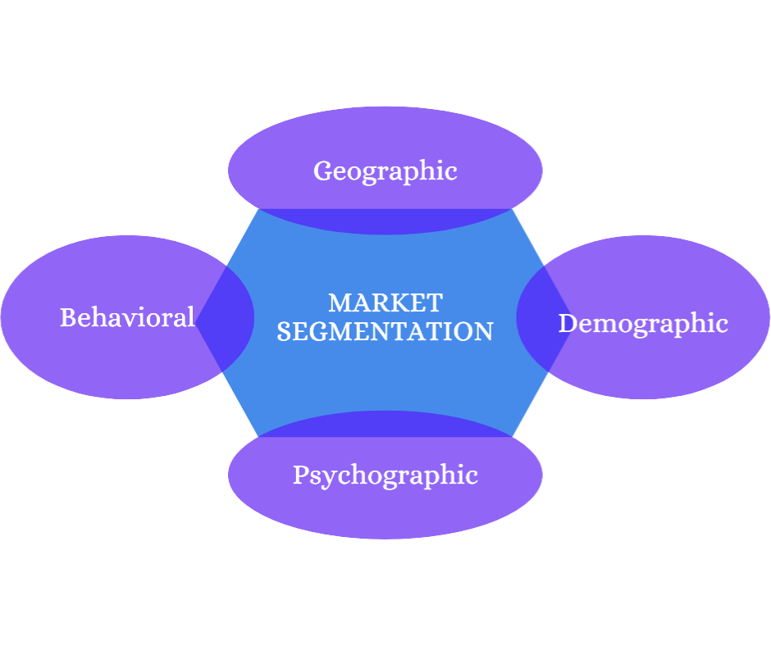

### **7.2 Types of Market Segmentation**

There are different types of market segments that you can create. Below are the four major types of Market Segmentation.

* **Geographic Segmentation:** Geographic Segmentation splits up your target segment based on locations such as country, state etc. Customers can also be identified by taking into account the characteristics of the area they live in for example language, urban, suburban, rural etc.

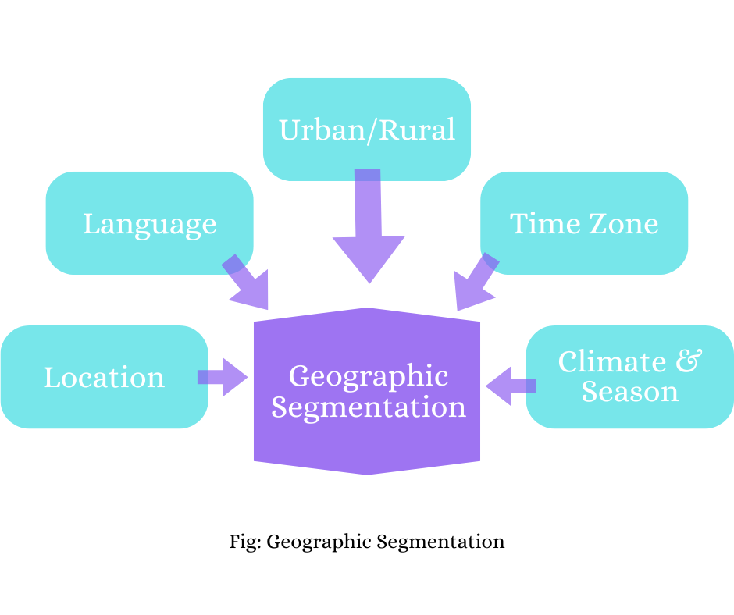

* **Demographic Segmentation:** This type of segmentation technique splits the target audience based on people-based differences. These factors include things like age, sex, marital status, family size, occupation, education level, income, race, nationality and religion.

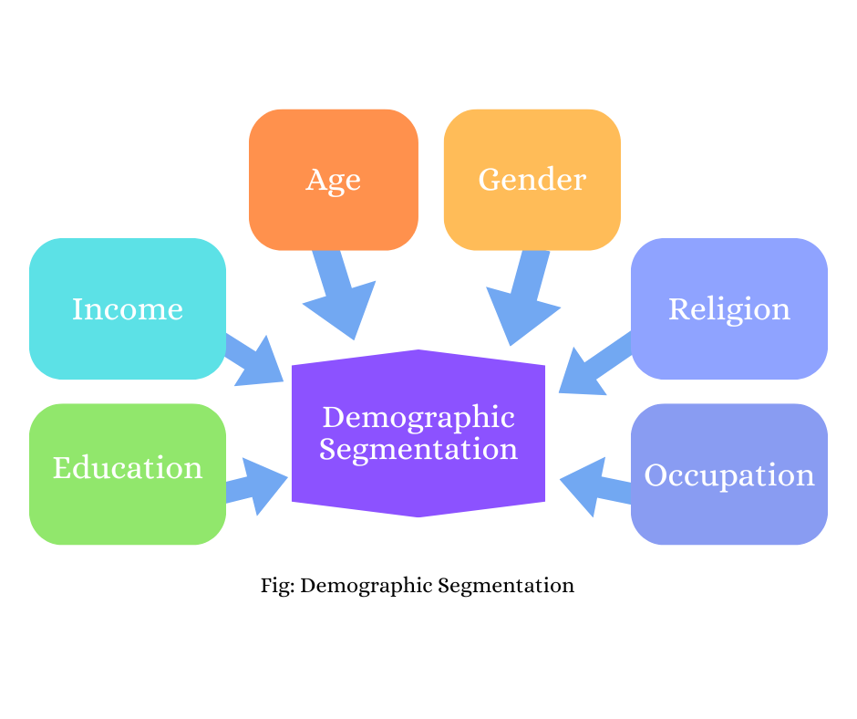

* **Psychographic Segmentation:** Psychographic Segmentation splits the target market based on characteristics that are mental and emotional. Some examples of psychographic characteristics include personality traits, interests, beliefs, values, attitudes and lifestyles.

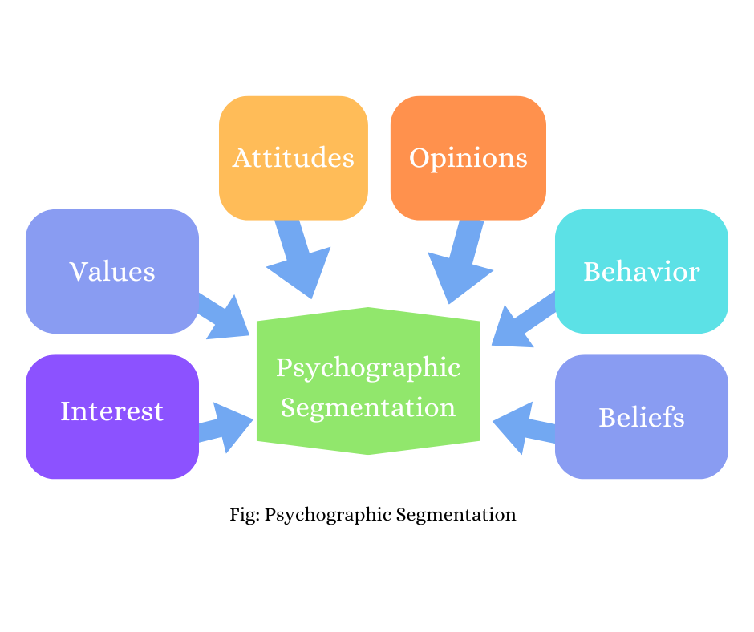

* **Behavioral Segmentation:** Behavioral segmentation is a form of marketing segmentation that divides the target market based on behavioral patterns exhibited. This segmentation type studies the behavioral traits of consumers — their knowledge of, attitude towards, use of, likes/dislikes of, or response to a product, service, promotion, or brand.

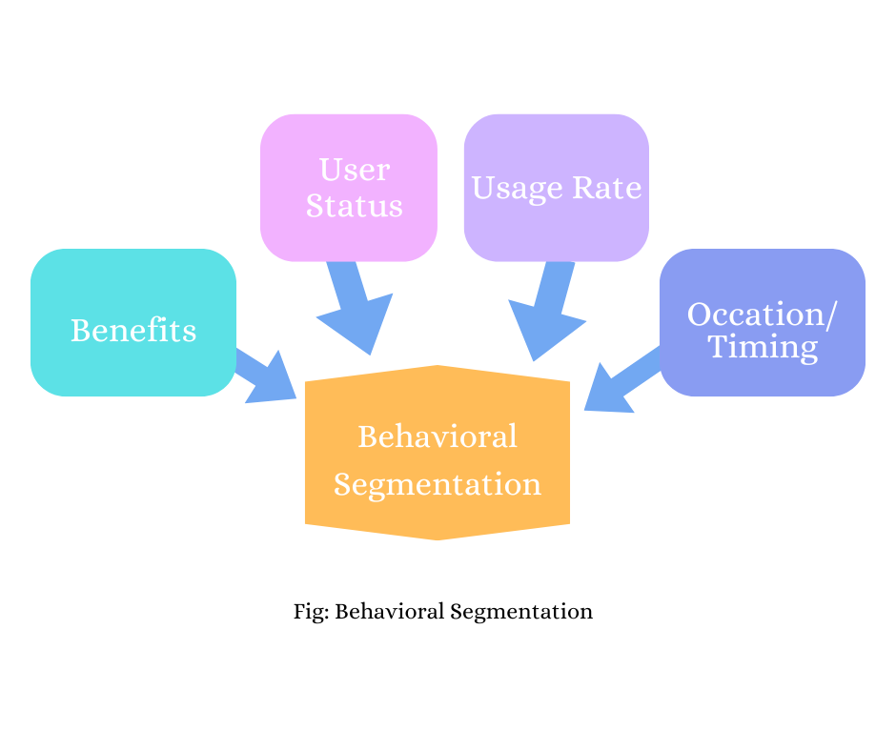

### **7.2 Visuals for Market Segmentation Description**

**Using Visuals:** It’s a good idea to use charts and graphs for making sense of the data! These visuals can show trends and how different variables affect the market, giving you a better overall view.

### **7.3 Checking Segment Variables**

**Statistical Testing:** Use some statistical methods to check how well segmentation is working, like p-tests, t-tests, sample distributions, and probability stuff.

**Model Performance Check:** Look at how well the segmentation model is doing by using metrics like the F1 score and R-squared score, which helps you know if the segmentation is effective and meaningful.

### **7.4 Predicting Segments with Variables**

**Building Models for Prediction:** You’ll want to create predictive models like regression classifiers and decision trees to sort segments based on the input variables. Test out these models on sample data to see which method works best.

**Binary Logistic Regression:** Set up a binary logistic regression model for binary classification variables. Use linear models with general parameters to guess segment membership correctly.

**Multinomial Logistic Regression:** For classes with more than two outcomes, use multinomial logistic regression with various metric variables. Make sure the model is flexible but not too overfitted, mixing different variables in a balanced way.

**Tree-Based Methods:** Think about using tree-based techniques like decision trees and random forests, especially when you’re dealing with nominal and metric descriptors. Mixing both methods while applying normalization and some statistical checks will help you avoid overfitting and build strong segmentation.

## **Step 8: Selecting the Target Segment(s)**

### **8.1 Get the Segmentation Team Together**

* **Gather Team Members:** Bring together the key people involved in segmentation and decision-making.

### **8.2 Figure Out Potential Target Markets**

* **Review Segments:** Look back at the market segments that were pointed out in Step 6 and detailed in Step 7.
* **Align with Organizational Objectives:** Concentrate on the segments that fit well with McDonald's goals and what they can do operationally.

### **8.3 Make Sure It Meets Knock-Out Criteria**

* **Reassess Criteria:** Check each segment against important criteria like being similar, different, size, how well it fits strategically, identifiable, and reachable.
* **Eliminate Non-Qualifying Segments:** Take away any segments that don't meet these main criteria.

### **8.4 Agree on Values for Attractiveness Criteria of Segments**

* **Define Attractiveness Values:** Talk it through and come to an agreement on how each market segment scores on things like growth potential, profit, and how easy it is to access.

### **8.5 Check Organizational Competitiveness for Each Segment**

* **Evaluate Competitiveness:** Look at McDonald's strengths in each segment, taking into account things like resources, brand recognition, and expertise in operations.

### **8.6 Figure Out Overall Attractiveness of Segments**

* **Score Calculation:** For each segment, multiply the attractiveness value by the weight you assigned to each criterion, and add these up to get a total score for attractiveness.

### **8.7 Calculate Organizational Competitiveness for Each Segment**

* **Competitive Scoring:** Figure out a total score for McDonald's competitiveness in each segment by multiplying the competitive values by their weights.

### **8.8 Plot Values on a Segment Evaluation Plot**

* **Visual Representation:** Make a matrix or a two-axis plot that shows segments based on their attractiveness and McDonald's competitive strengths.

### **8.9 Make a Preliminary Selection of Target Segments**

* **Select Viable Segments:** Use the evaluations and the plot to pick out the segments that look the most promising as potential targets.

### **8.10 Check Compatibility Among the Chosen Segments**

* **Check Segment Compatibility:** If targeting several segments, ensure that they work together and can be approached without conflicting strategies.

### **8.11 Present to the Advisory Committee**

* **Share Results for Feedback:** Show the selected segments to the advisory committee for review, being open to changes based on what they say.

### **8.12 Finalize Target Market Segments**

* **Conclude Selection Process:** Finalize the choice of target segments with approval from all stakeholders, ensuring alignment with McDonald's strategic goals.

## **Step 9: Customising the Marketing Mix**

### **9.1 Understand Implications for Marketing Mix Decisions**

* **Adopt the 4Ps Model:** Focus on customizing the 4Ps — Product, Price, Place, and Promotion — to develop a well-rounded marketing strategy for the selected market segments.
* **Follow the STP Approach:** Use the Segmentation-Targeting-Positioning (STP) model. Segmentation and targeting help identify the right segments, while positioning ensures the product appeals distinctly to meet the unique needs of each segment.

### **9.2 Product**

* **Align Product Specifications with Segment Needs:** Customize McDonald’s menu items, packaging, and branding to match the preferences and needs of each segment.
* **Product Attributes:** Adjust aspects such as design, features, and quality based on customer expectations in each target segment, including healthier options, value meals, or specialty items that resonate with specific demographics.

### 

### **9.3 Price**

* **Set Competitive and Attractive Pricing:** Balance pricing to cover costs and be competitive within each segment's budget. McDonald’s could use varied pricing strategies, such as value-based pricing for cost-conscious customers or premium pricing for high-quality offerings.
* **Consider Pricing Strategies:** Explore strategies like penetration pricing to attract a broad customer base, skimming pricing for premium items, or discount pricing for loyalty programs.

### **9.4 Place**

* **Select Optimal Distribution Channels:** Ensure that McDonald’s products are easily accessible through the preferred channels of each segment, whether physical locations, drive-thrus, or online platforms.
* **Manage Inventory and Logistics:** Coordinate logistics and inventory to meet demand without delay, focusing on locations with high traffic for specific segments, like urban centers or suburban areas, depending on segment preferences.

### **9.5 Promotion**

* **Customize Promotional Strategies:** Develop targeted advertising, sales promotions, and other communications that resonate with each segment’s interests and values. For example, emphasize convenience and quick service for busy customers, or highlight quality and sustainability for health-conscious consumers.
* **Engage Through Various Channels:** Use a mix of digital marketing, social media, local events, and in-store promotions to reach each segment effectively and enhance McDonald's brand visibility.